ADVISORY BOARD  George Barna  Barna Research, LTD.  Rev. Dave Cunningham  Illinois  Rich Dauer  Colorado Rockies Org. Coach  Bob Dehart  Bridgestone/Firestone – ret.  Tim Drew  Professional Baseball – ret.  Rob Eggers  Former Indiana U. basketball  Pat Gould  Deloitte & Touche  Marshall Jennings  Jennings Htg & Air, Akron, Oh  Terry Lawrence  Sales  Andy McCollum  Detroit Lions  George Mitchell  Owner, DiscountFence.com  Jimmy Oliver  Pro Basketball – ret.  Mike Rupp  New Jersey Devils, NHL  Jim Smith  Ohio Highway Patrol – ret.  ON A PERSONAL NOTE!  Our original AAU programs have been replaced with John’s natural involvement in the lives of his own children. This includes three levels of youth soccer, two different youth baseball teams, three youth basketball teams, and the church’s AWANA program. John is also coaching Streetsboro Middle School’s 8th grade basketball. This has provided a broad foundation for numerous relationships similar to the fruit John Wells ministry has produced (see newsletter story on the Wells family).  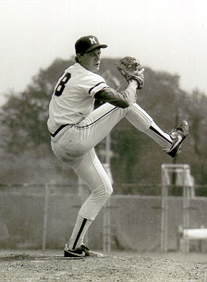  Joe Lazor  When John was in college, he used to help out Joe’s youth baseball team. Joe went on to be named to Medina HS, Medina County, and Mount Vernon Nazarene College’s halls of fame. He also was a major league draft pick of the Cincinnati Reds and playing at the Triple A level. Now he serves on TEAM JAM’s board of directors. | PRO BASEBALL  We completed our fifth year as chaplain of the Mahoning Valley Scrappers, the rookie minor league team of the Cleveland Indians system. Shawn Lazarus completed his first season as chaplain of the Indians Double A affiliate, the Akron Aeros. We have access to all Indians draft picks and now are able to team together to maintain better relationships throughout their rise in the organization. We also have more opportunities to meet and see visiting players we already know. We usually have even greater responses from opposing players, even though the Indians have responded very well..  Our chapels at Mahoning had 50% of the team participate regularly. Numerous players have passion for ministry and will dynamically impact others for Christ whether or not they continue playing ball. Visiting team chapels were often even better attended.  Tug Hulett was traded last off-season last from Texas to the Seattle Mariners (where his Dad, Tim, is also a minor league manager). He almost made the majors out of Spring Training but his torrid hitting eventually helped him break into the majors by July. A unique blessing took place during Seattle’s lone trip to Cleveland in August. Tug and John were able to get together after a Saturday night game in which Tug hit his first big league homerun (to beat our Indians), and John was “coincidentally” asked by the Indians chaplain to sub as a chapel speaker. That means that the first major league chapel John had ever spoke at was for the Indians and Tug Hulett’s Mariners. Having met 3 years ago in Dayton, Ohio, it was an obvious statement from God for both Tug and John..  Drew Sutton (Astros Double A) had an outstanding season and fall league, being named the Astros Double A player of the year. He was also added to the Astros 40 man roster.    J.R. Towles (Houston Astros) made the Astros roster out of Spring Training. Ben Zobrist (Devil Rays) fought thru some injuries early in the season to help lead Tampa to the 2008 World Series against Philadelphia. He and his wife are also expecting their first child in early 2009. Cody Strait was traded to the Kansas City Royals where his testimony enabled Shawn Lazarus to spend time with a couple of his new teammates (Jeff Bianchi, Matt Morizio) who then paid to have their own testimony cards designed by us.  Because of Baseball Chapel, we now have relationships with over 75 additional players and personnel in several organizations.  Sixteen years ago we only knew one pro baseball player, Joe Lazor (Medina HS, Reds & Pirates). It’s pretty obvious what God is planning to do in the future. | CHAPELS  We are fortunate to still be permitted to be chaplain for Hudson HS and (for the first time) for Streetsboro HS’s football teams. This is in addition to Shawn serving as chaplain of the Akron Aeros and John as chaplain for Mahoning Valley (see Pro Baseball article on left).  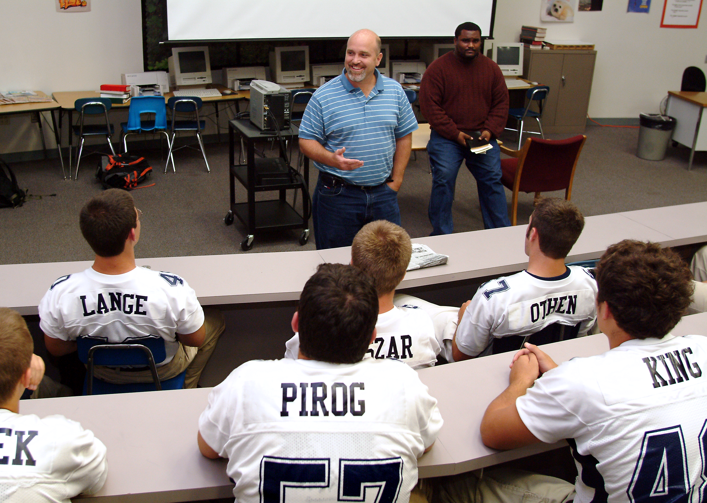  A new development came by way of the college football teams that were visiting Ohio. Through the network that Shawn has developed, requests continue for chapel speakers. If he is not geographically able, he arranges others to speak. This year he spoke to both Ball State (ranked 16th in country), and Buffalo, and was asked to arrange chapels for Ball State two more times. The highlight of these experiences however was definitely the Ball State chapel before the Akron game.  Ball State’s head football coach, Brady Hoke, was Shawn’s position coach when he played at Michigan. Shawn wasn’t a Christian back then and was looking forward to explaining to his favorite coach what Christ had done in his life. Through Shawn’s example and words (asking for forgiveness for his immature decisions in college) his life was testimony that motivated Coach Hoke, a couple other coaches and approx. 50 players to verbally and publicly trust Jesus Christ as Savior.  At Hudson, teacher/coach Jeff Hildebrand has been a tremendous blessing. Jeff surrendered his life to Christ on the 50 yard line of the Solon HS football field during pre-game warm-ups in 2005 and has matured rapidly. This season he again organized all the chapels for his high school football team and began an FCA group that meets bi-weekly at Hudson’s Middle School. At the conclusion of the 2008 school year, Tony Stockman (Medina, Ohio State and Foreign basketball) and the Divine Soldiers provided the closing program.  Meanwhile, Streetsboro HS’s experience was tremendous. Head football coach John Arlesic met with John weekly to learn and put into practice our Spiritual Leadership information. Not only did he make a commitment personally, but he made it possible for John to meet with the leaders on his team during the school day. Many relationships were developed in the upper grade levels, supplementing the work already established in the 4th thru 9th grades. Several key varsity athletes surrendered their lives to Christ. | RIVALS TEAM UP  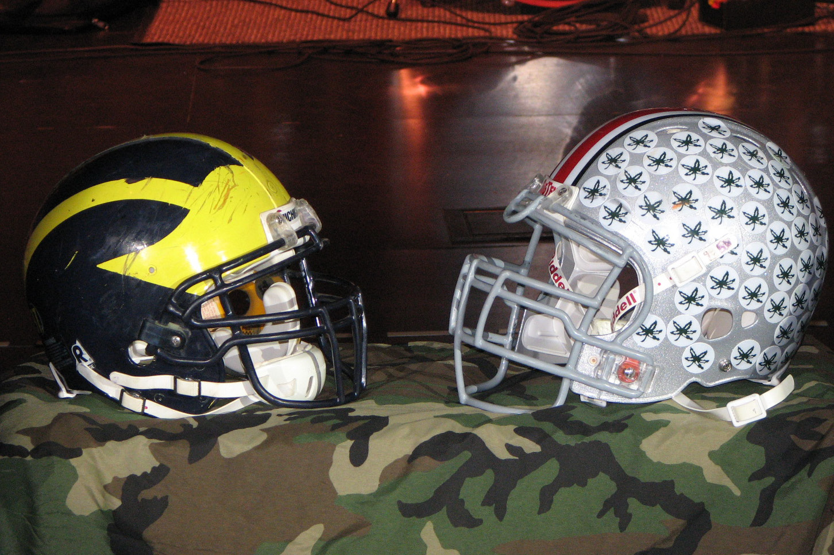  The relationships that Joel Penton (Ohio State) and Shawn Lazarus (Michigan) have made thru football continue to multiply as a result of their  Rivals TEAM UP ministry together. “Team Up” brings these former rivals to defend youth against life’s greatest opponent (the Devil), by speaking about their football rivalry and their common faith in Jesus Christ.  Though they speak often together to church or ministry groups throughout Ohio and Michigan, we believe the even greater work is being accomplished among their athletic peers. Former teammates have been contacting them throughout the year and meeting with them at the annual game. This year we had eight athletes share their testimony on WCRF (Moody radio in Cleveland) in the weeks leading up to the game. This was another efficient ministry as hundreds of thousands of listeners were impacted (in addition to replays on the Rivalsteamup.com website) without any financial investment.  FAITHFUL SUPPORTERS  The core of our ministry support comes from five churches. Their combined support equals $17,000. Maranatha Bible of Akron is the primary sponsor behind Shawn Lazarus’ ministry to the Akron Aeros professional baseball team. West Hill Baptist (Akron) has faithfully supported the longest, since 1991. Medina First Baptist has been our most generous supporter, since 1994. Hope Community (Hudson) also continues supporting us financially and serves as a ministry partner. Faith Baptist (Streetsboro) generously allows us to use their church gym for athletic outreach. In His Steps Foundation graciously granted our request for $2,000 to develop leaders. These ministries are a great example of how we can TEAM together to reach people in the community whom haven’t necessarily been involved with church.  FINANCES  Donations at the end of 2008 made it possible for us to end the year “in the black”. No compensation is provided for any staff with these funds. Donations are used strictly to help defray costs that are necessary to help us communicate with young adult leaders or children. This year we are presently $7,000 under budget

